Joint Optimal Service Chain Allocation, VNF instantiation and Metro Network Resource Management Demonstration

Author name(s) [10-point type, centered, bolded]
¹Universidad Politécnica de Cartagena, Cuartel de Antiguones, Plaza del Hospital 1, 30202 Cartagena, Spain
Email: javier.moreno@upct.es

Abstract: In a metro network with VIMs orchestrated by an ETSI-OSM instance, and an optical transport controller, we demonstrate optimized service chain provisioning using the open-source Net2Plan tool with interfaces to OSM (new) and transport controller.
OCIS codes: (060.4250) Networks; (060.4256) Network Optimization.

1. Introduction
Metropolitan area networks play an essential role in telecom operators’ infrastructure to satisfy the near-future requirements of the 5G era. Among other key performance indicators, 5G networks are expected (i) to use a scalable management framework enabling fast deployment of novel applications, (ii) to reduce the network management OPEX by at least 20% compared to today and (iii) to ensure End-to-End latency below 1 ms. Software-defined networking (SDN) network function virtualization (NFV) are key technologies to address (i) because they enable dynamic management of virtual network functions (VNFs) across an advanced programmable network. Moreover, (ii) can be met instantiating VNFs in standard commodity hardware and exploiting hardware disaggregation and multi-vendor interoperability with SDN. Finally, optimization is imperative to guarantee (iii) by fully exploiting the network resources and allocating service chains (SCs) of multiple VNFs in the most efficient manner.
In this context, the Metro-Haul project [1] proposes cost-effective, energy-efficient, agile and programmable metro networks that are scalable for 5G access and future requirements, encompassing the design of all-optical metro nodes (including full compute and storage capabilities), which interface effectively with both 5G access and multi-Tbit/s elastic core networks. The Metro-Haul network model proposes an architecture based on two different computational-aware nodes, Access Metro Edge Node (AMEN) and Metro Core Edge Node (MCEN), MCEN is able to manage much more IT resources than AMEN due to its proximity to the core network. Storage and computational capacity are essential to build a SDN-NFV-based management framework enabling fast configuration time to set up or reconfigure services handling 5G applications, and this is where this work plays a main role.
2. Overview
This demonstration proofs the use of the specialized open-source planning tool Net2Plan [2] to assist the NFV-Orchestrator (NFV-O) Open-Source MANO (OSM) [3] in the optimal VNF instantiation, SC allocation and optimization of transport network. An overview of the demonstration is shown in Fig. 1, a complete dissemination of the control (IT and network) modules that compose this architecture is explained as follows:
- OSS: operational support systems, represents an operator which deploys an application service given to users. The Net2Plan GUI emulates operator’s behavior.
- NFV-O, it is represented by OSM which is in charge of the virtualization infrastructure, OSM manages and deploys VNFs leveraging hierarchically in VIMs so that storage and computational resources are taken into account.
- Netphony, is a BGP-LS Speaker, a Traffic Engineering Database and a Topology Module pointed to afford an overview of the emulated transport network, it contains the T-SDN controller.
- SCCE: is an evolution of the well-known Path Computation Element (PCE) taking into account not only path routing but also is capable of solve service chain allocation problems. Tasks of the SCCE are managed by the planning tool Net2Plan.
The proof of concept also demonstrates the use of the following open interfaces:
- OSS-SCCE:
- OSM and Net2Plan (I-PNFVO). For the purpose of this demonstration, we define a REST-API for planning and placement via the Virtual Infrastructures Managers (VIMs) of the Virtual Machines (VMs) and VNFs.
- SDN controller and Net2Plan (I-PSDN): We demonstrate the use of a standard topology interface based on REST Transport (T)-API to provide detailed multi-layer topological information of the transport network to the planning tool.
- Operator and Net2Plan (I-POSS): For the purpose of this demonstration, we develop a GUI? so that the operator can either manually decide where to instantiate VNFs, allocate a SC or run an optimization algorithm.
Seguir con un parágrafo de “Demonstration operation / workflow”. He colocado este asunto en el mail.
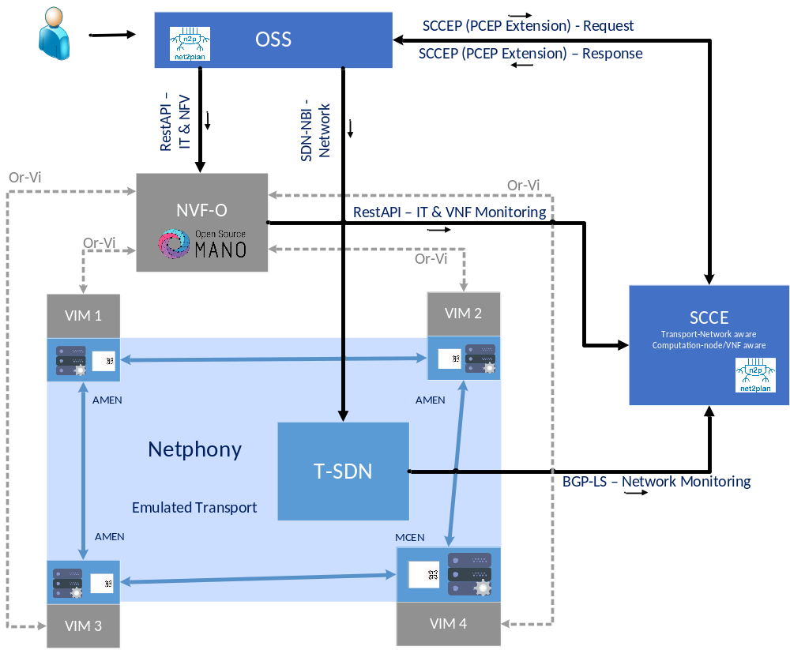
Fig. 1. Demonstration overview. NFV-O: Network Function Virtualization - Orchestrator. OSS: operational support systems VIM: Virtual infrastructure manager. Netphony: BGP-LS Speaker and Traffic Engineering Database
3. Innovation
Texto anterior.
Es OSM reciente? Hay otra gente que ya lo haya usado y/o definido interfaces para comunicarse con OSM?
Además, explicar que respecto a las demos del año pasado (que “solo” definían interfaces) nosotros estamos un paso adelante porque usamos algoritmos de optimización (open-source available).
4. OFC Relevance
Acknowledgments
The research leading to these results has received funding from the European Commission for the H2020-ICT-2016-2 METRO-HAUL project (G.A. 761727). INSPIRING-SNI???.
References
- Metro-Haul Project. https://metro-haul.eu/
- P. Pavon-Marino et al., “Net2Plan: An Open Source Network Planning Tool for Bridging the Gap between Academia and Industry”, IEEE Networks, Sept. 2015.
- Open Source Mano. [Online]. Avalilable: https://osm.etsi.org/
- Añadir algunas de las refs de demostraciones OFC 2017.

